**Exercise 1: Logging Error Messages and Warning Levels**

**Main class**

import org.slf4j.Logger;

import org.slf4j.LoggerFactory;

public class LoggingExample {

private static final Logger logger = LoggerFactory.getLogger(LoggingExample.class);

public static void main(String[] args) {

logger.error(" This is an error message");

logger.warn(" This is a warning message");

logger.info("This is an info message (optional)");

logger.debug(" This is a debug message (optional)");

logger.trace("This is a trace message (optional)");

}

}

**Dependencies**

<dependencies>

<dependency>

<groupId>org.slf4j</groupId>

<artifactId>slf4j-api</artifactId>

<version>1.7.30</version>

</dependency>

<dependency>

<groupId>ch.qos.logback</groupId>

<artifactId>logback-classic</artifactId>

<version>1.2.3</version>

</dependency>

</dependencies>

**OUTPUT:**

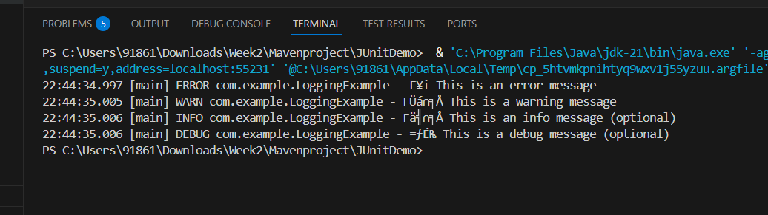

<dependency>

<groupId>ch.qos.logback</groupId>

<artifactId>logback-classic</artifactId>

<version>1.2.3</version>

</dependency>

</dependencies>